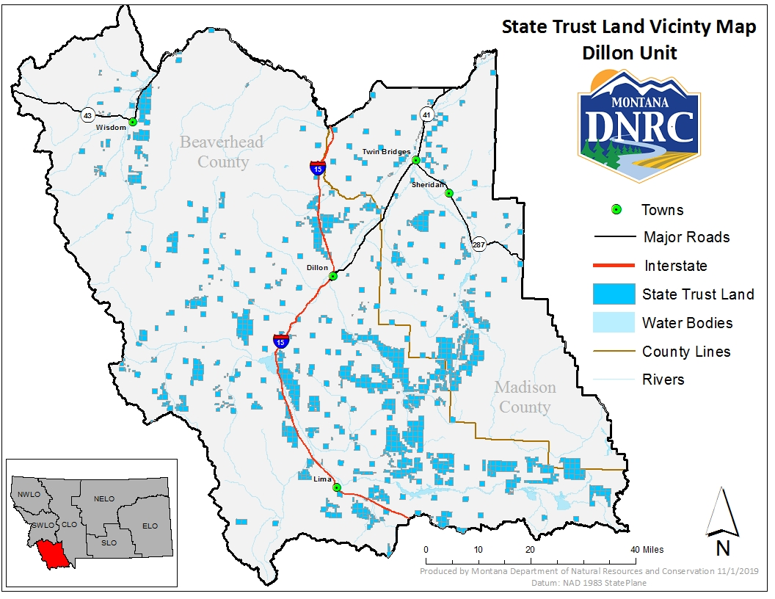

***WHISKEY SPRING TIMBER SALE VICINITY MAP***

**Whiskey Spring Timber Sale**

**Project Location:**

**Sections: 1, 2, 11, 14, 15, 22, 23, 24 Township: 12S Range: 12S 6W**

**County: Beaverhead**