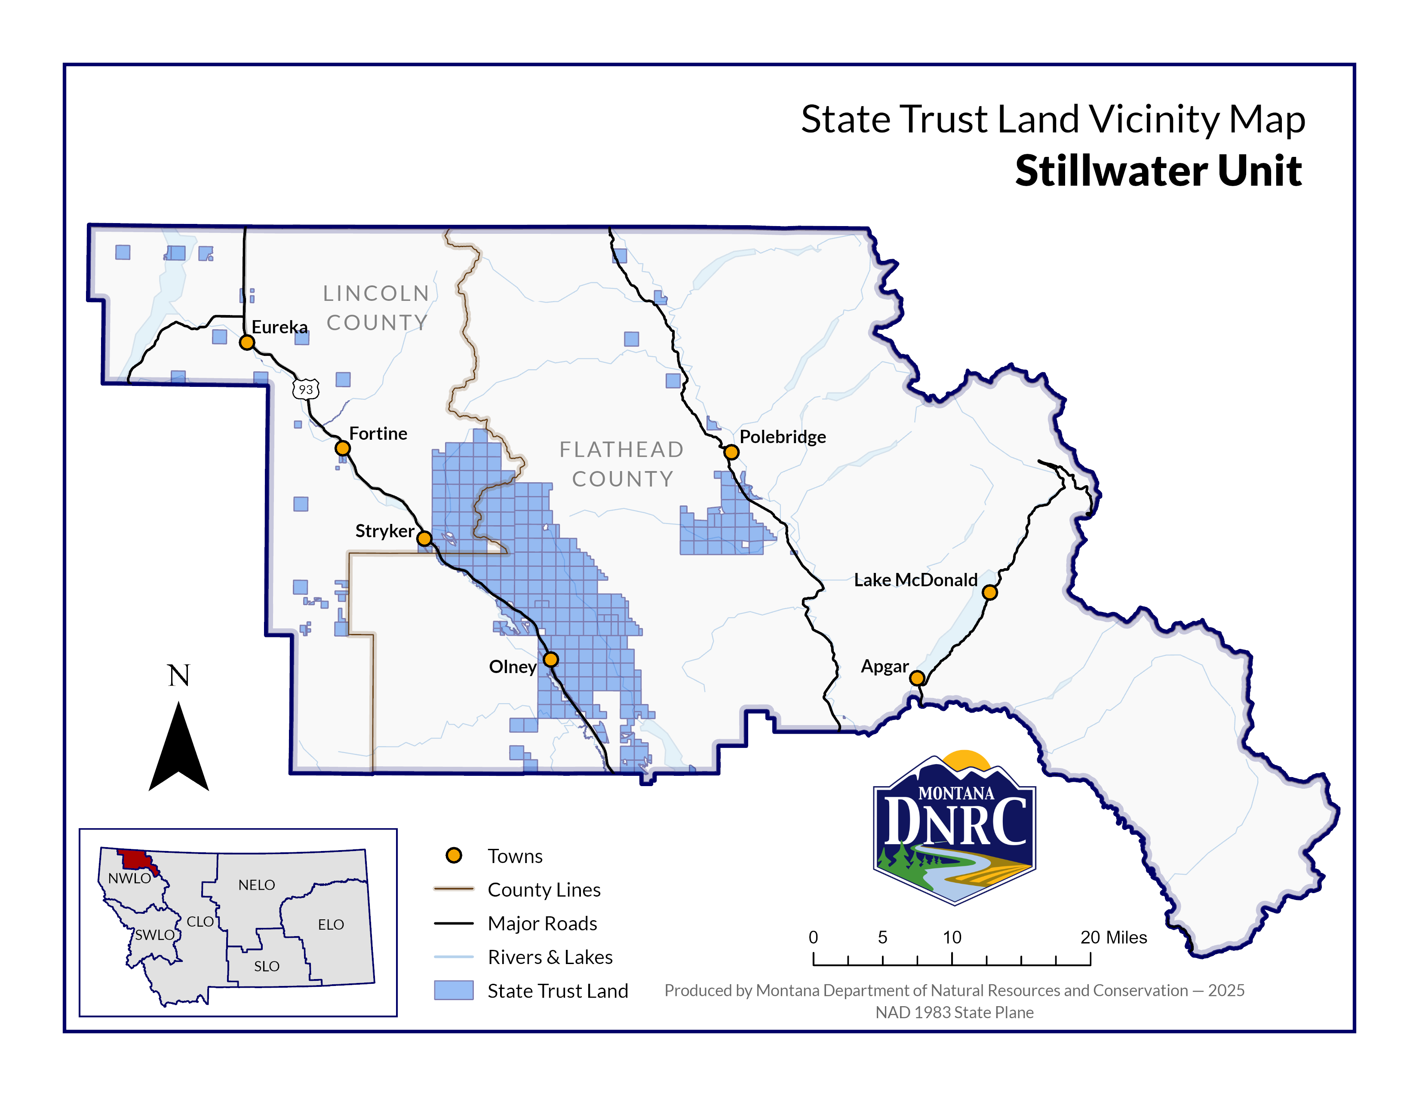

**Sections: 22, 23, 25, 26, 27, 34, 35, and 36**

**Township: 33N**

**Range: 23W**

**AND**

**Section: 9**

**Township: 32N**

**Range: 23W**

**County: Flathead**

*Swift Stryke Timber Sale*