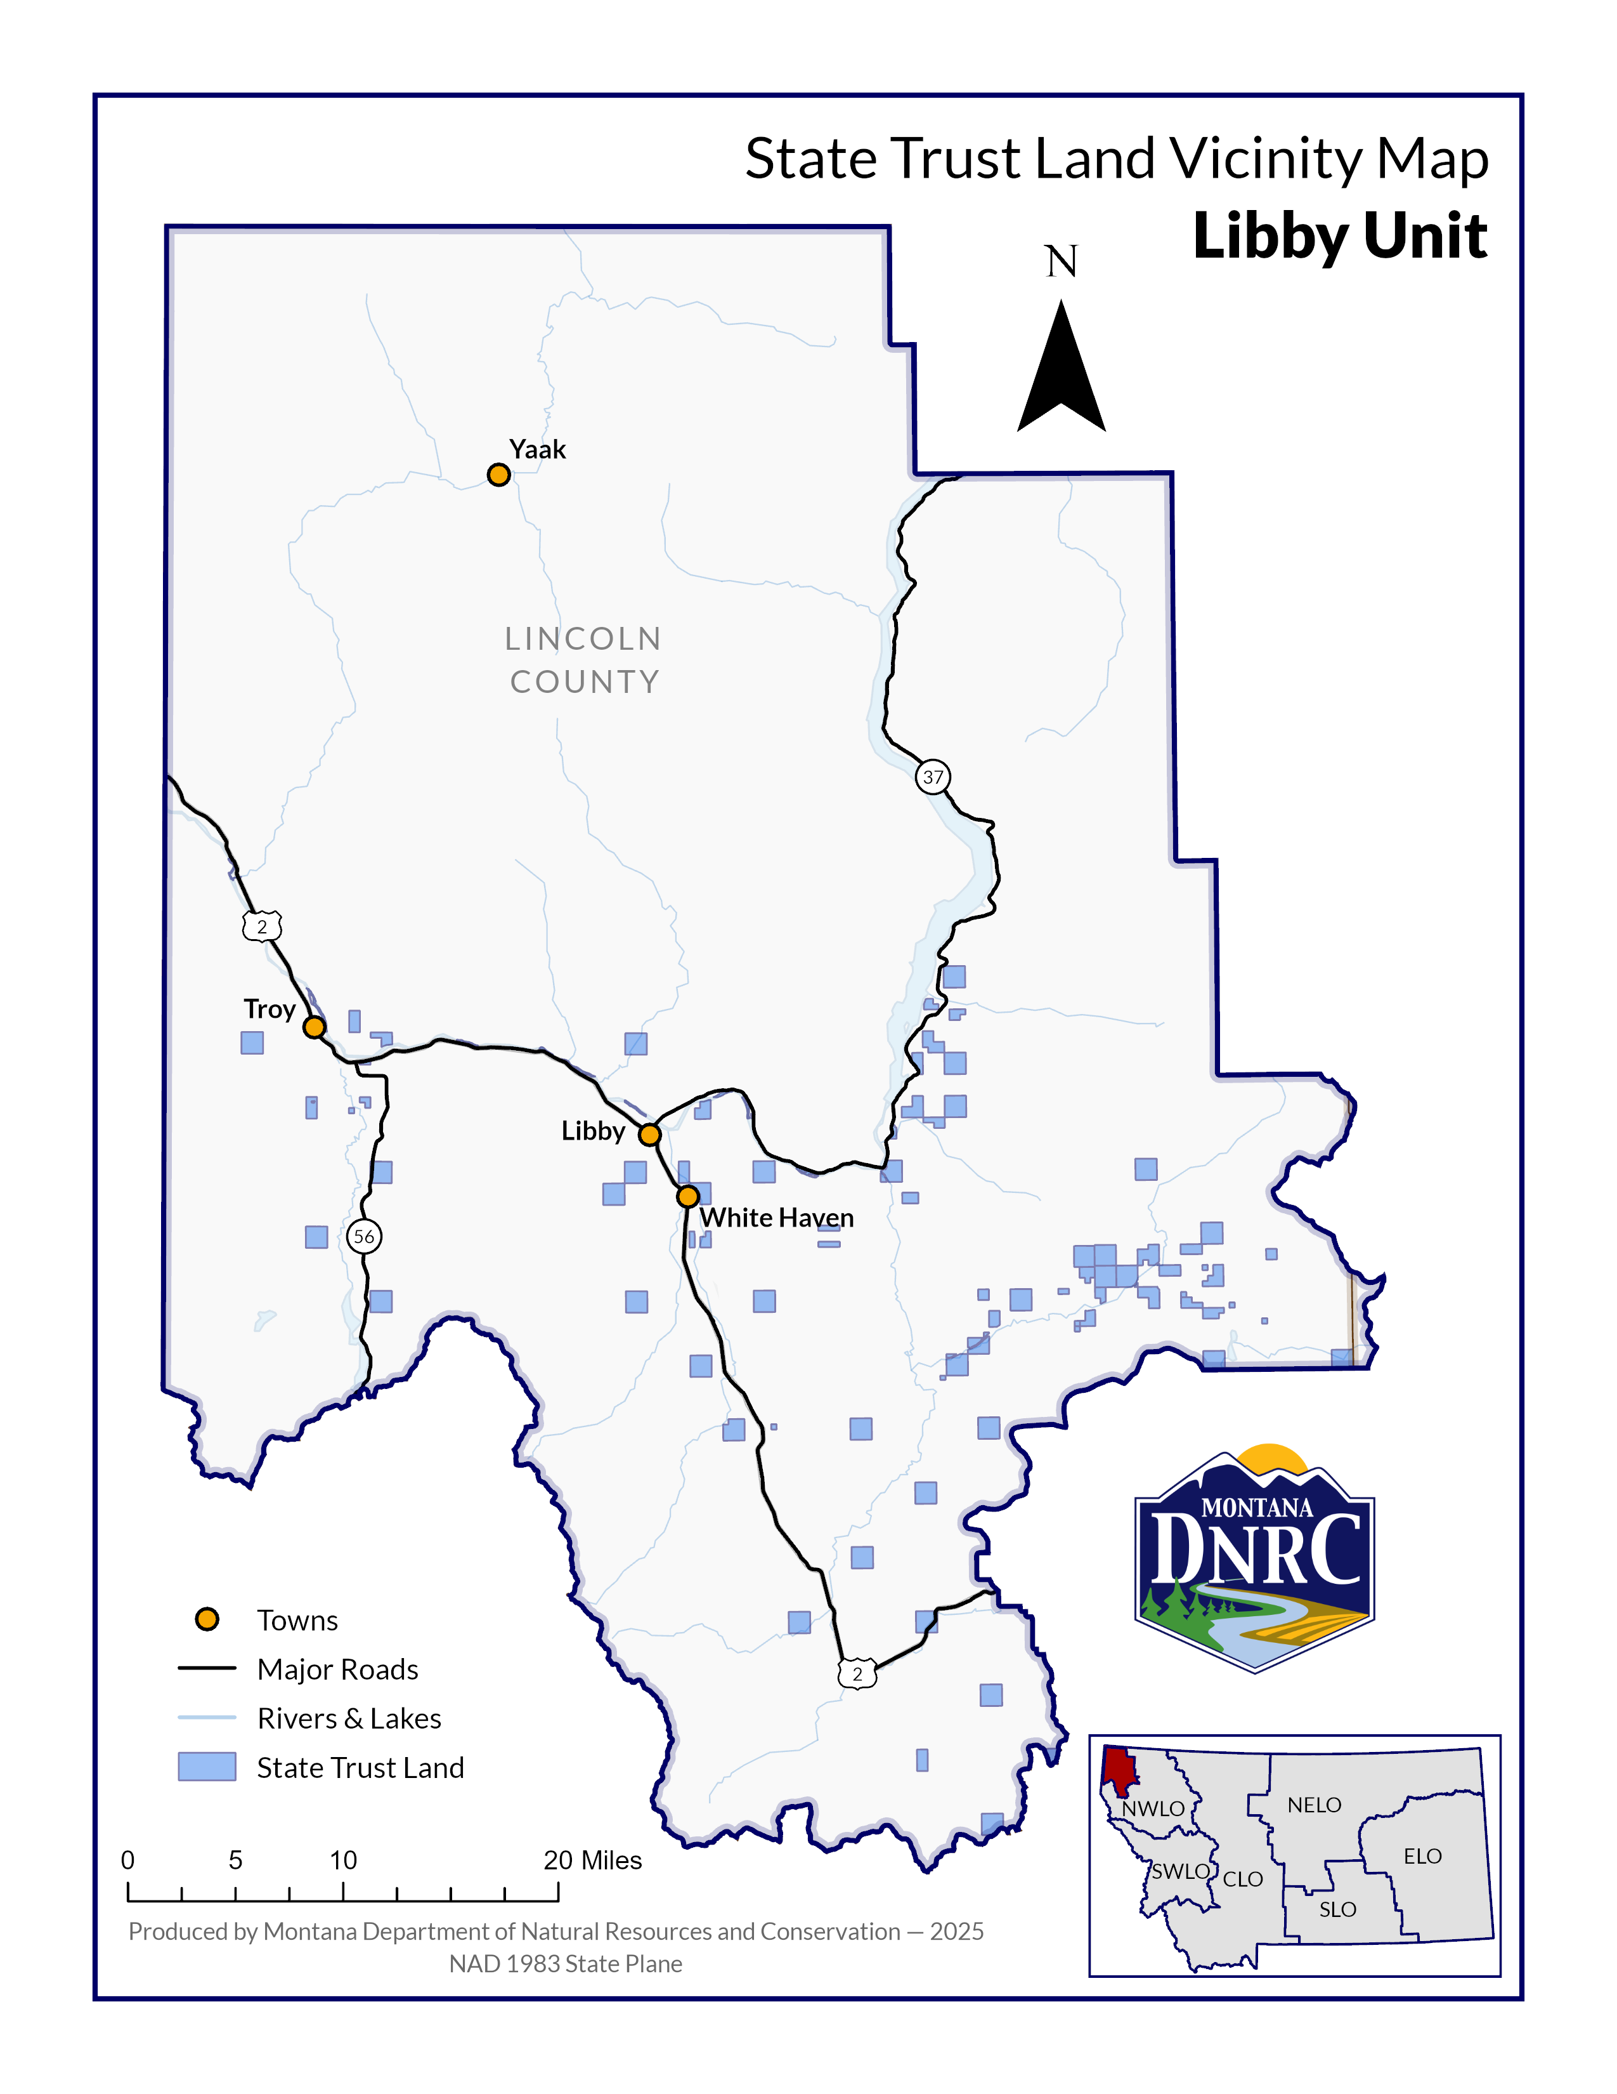

*8% Timber Sale*

**Section: 36**

**Township: 31N**

**Range: 31W**

**County: Lincoln**